

**Tribhuvan University**

**Faculty of Humanities and Social Sciences**

**Project Proposal**

**On**

**Futsal Management System**

**Submitted to**

**Department of Computer Application**

**Everest Innovative College**

***In partial fulfillment of the requirements for the Bachelors in Computer***

***Application***

Submitted by

ROHAN SHRESTHA

6th Semester, 2019 Batch

Reg. no: 6-2-713-21-2019

May 2023



**Tribhuvan University**

**Faculty of Humanities and Social Sciences**

**Everest Innovative College**

Solteemode, Kathmandu

Bachelor in Computer Applications (BCA)

# LETTER OF APPROVAL

This certify that this proposal is prepared by **Rohan Shrestha** entitled **“Futsal Management System”** in the Partial Fulfillment of requirement for the degree of Bachelor in Computer Application has been evaluated. In our opinion it is satisfactory in the scope and quality as a project for the required degree.

Kishor Kafle

Program Coordinator

Everest Innovative College

Solteemode, Kathmandu

Basanta Chapagain  
Internal Examiner

BCA Department

Table of Contents

LETTER OF APPROVAL i

List of Figures iii

List of Tables iv

List of Abbreviation/Acronym v

Introduction 1

Problem Statement 1

Objectives 2

Scope 2

Methodology 3

A. Requirement Identification 3

1. Study of Existing System 3

2. Literature Review 3

3. Requirement Collection 4

B. Feasibility Study 5

1. Technical Feasibility Study 5

2. Operational Feasibility Study 6

3. Economic Feasibility Study 6

C. High Level Design of System 7

1. Methodology to be used 7

2. Working Mechanism of System 8

3. Description of Algorithm 11

4. System Developments Tools 13

Gantt Chart 14

Expected Outcome 15

References

# List of Figures

Figure 1: Waterfall Model 7

Figure 2: ER-Diagram of FMS 8

Figure 3: Context Diagram of FMS 9

Figure 4: Level 1 DFD of FMS 10

Figure 5: Geohashing Algorithm Explanation 12

Figure 6:Gantt Chart of FMS 14

# List of Tables

Table 1: Technical Feasibility Study Table 5

Table 2 : Gantt Table of FMS 14

# List of Abbreviation/Acronym

|  |  |
| --- | --- |
| **Abbreviation/Acronym** | **Description** |
| CSS | Cascading Style Sheet |
| DB | Database |
| ER | Entity Relationship |
| FMS | Futsal Management System |
| HTML | Hypertext Markup Language |
| MS | Microsoft |
| SDLC | System Development Life Cycle |

# Introduction

Futsal is a variant of soccer that is played indoors on a smaller field with a smaller ball and a reduced number of players per team. This web application provides varieties of futsal located inside Kathmandu area which can be booked through online.

This project's main objective is to build a platform for connecting futsal business owners and customers. This system is an online booking tool created to make it simple for customers to reserve the futsal they want for the time that works best for them. The futsal business owner can easily list and manage all of their varied services here. Customers who are interested in booking futsal can browse all of the alternates and book the futsal easily on short period of time. The physical appearance-based booking process for futsal will be replaced by this web application. This project will also make it simple to navigate to the futsal court, as finding a futsal court requires a lot of effort, time and frustration. Along with simple bookings and a variety of payment options through the web application, it will also offer customers a seamless and organized experience. This project will be a web-based application that will be built with HTML, CSS, Bootstrap, JavaScript, React, Bootstrap, Java and Spring framework.

# Problem Statement

Numerous futsal organizations are currently operating in a respectable manner, but there is potential for increased productivity. Few of them are successful in their attempts to gather as much exposure as they can from different social media platforms. And in today's digital age, the easiest way to boost productivity is through online marketplaces. The greatest solution is to switch to digital. Although very few of them have adopted digital technology, many are still lagging behind. They don't actually object to going digital. It's only that creating an online platform for them would be rather pricey. They don't receive enough attention as a result.

One of the major problems with booking futsal in Nepal is the lack of online booking platforms and a centralized system for managing futsal facilities. Many futsal facilities in Nepal still rely on traditional methods of booking, such as phone calls or in-person reservations, which can be time-consuming and inefficient. It is also difficult to search the location of specific futsal properly as there is no proper navigation of that venue. Additionally, the demand for futsal facilities in Nepal has been increasing rapidly in recent years, but the supply of quality facilities has not kept up with this demand. As a result, it can be difficult for players and teams to find available futsal facilities at convenient times, especially during peak hours or weekends. And the lack of transparency in pricing and scheduling, with some futsal facilities charging higher rates during peak hours or for popular time slots are also the major problem. This can create confusion and frustration for players and teams who are trying to book a futsal facility at a reasonable price.

Due to the lack of a suitable platform to meet their needs and requirements, both the owner of a futsal business and its customers must deal with numerous shortcomings. These issues can be resolved by creating a suitable interface between them, where the owner of a futsal facility can offer their numerous services and potential clients can review all of the possibilities before booking a futsal. In the modern digital world, the internet has the answer to any difficulty. FMS project will eventually provide the best way to book futsal in Nepal.

# Objectives

The main objective of this project is to provide best features for both parties as mentioned below:

• To locate the nearest available futsal court using Geohashing algorithm

• To reserve the futsal for the time that works best for the customers

# Scope

Enhancing operational effectiveness, customer satisfaction, and financial success is the primary goal of this initiative. Organizations that are not for profit will use the system. Every type of user with a profile in the application can access this system, and the owner of the futsal facility can post information about their organization and customer can reserve a court.

# Methodology

## Requirement Identification

### 1. Study of Existing System

The current system in the Futsal Court that has been used by the staffs and customers are only the manual system. This manual system operates by recording all the booking data in a log book. Users need to call or come to the Futsal Court by themselves to check the availability of the court. After that, staffs need to check the logbook to see the recorded booking data. If the court is available at the needed time, customers can proceed with their booking process. And staffs will update the booking data in their logbook. However, if the court is not available and has been booked, the booking process will automatically terminate.

### 2. Literature Review

Futsal is a rapidly growing sport around the world, and its popularity has led to an increase in the number of futsal facilities. As a result, the need for efficient futsal management systems has also increased. Several studies have focused on the development and implementation of futsal management systems to improve operational efficiency, customer satisfaction, and financial performance.

[**hamrofutsal.com**](https://www.hamrofutsal.com)

hamrofutsal.com is a domestic online website for booking a futsal. The website was informative was easy to navigate and use. But it is not working properly at the moment as it is on trial phase. It can show futsal from different cities but right now it is not working. This was not so nice experience to use the website. [1]

A futsal management system using the internet of things (IoT) technology. The system allowed customers to book futsal courts online, while facility administrators could manage court availability, league scheduling, team registration, and financial tracking. The authors found that the system improved operational efficiency and customer satisfaction and reduced energy consumption. [2]

FMS using the cloud computing platform. The system allowed customers to book futsal courts online and track their booking histories, while facility administrators could manage court availability, league scheduling, and financial tracking. The authors found that the system reduced administrative workload, increased customer engagement, and improved data security. [3]

A web-based futsal management system for a futsal facility in Portugal. The system allowed customers to book futsal courts online, while facility administrators could manage court availability, league scheduling, team registration, and financial tracking. The authors found that the system improved operational efficiency, increased customer satisfaction, and generated additional revenue for the facility. [4]

In conclusion, the literature suggests that futsal management systems can improve operational efficiency, customer satisfaction, and financial performance. The studies highlighted the importance of user-friendly interfaces, efficient database design, secure data storage, and data analytics for futsal management systems. Further research is needed to investigate the long-term impacts of futsal management systems and their potential to drive innovation in the sports industry.

### 3. Requirement Collection

The functional and non-functional requirements of the application are given below:

**Functional requirements**

Functional requirements are the features that the developing system must have. The functional requirement of that we identified are:

**For Admin**

* The system should allow admin to login and logout of the system
* The system should allow admin manage the customers and futsal owners.
* The system should have feature to allow admin to manage contact us query.

**For Customers**

* The system should be able to login/signup users in the system.
* The system should allow user to explore the various futsal.
* The system should allow user to view the reservation.
* The system should allow user to edit their profile information.
* The system should allow user to communicate with futsal.
* The system should allow user to change their password.

**For Futsal Owner**

* The system should allow user to add their Futsal information.
* The system should allow user to edit and delete the information.
* The system should allow user to change their password.
* The system should allow user to monitor payment status.
* The system should allow user to view details of the person booking the futsal.

**Non –functional requirements**

Non-functional requirements make the functioning of the system easier and effective. The non–functional requirements of this project are:

* **Performance**

The web-application will be simple, small-scale project, which can work effectively on limited hardware capability. Overall load time is reduced to increase the performance.

* **Availability**

Users can access to the services of the application on time every time. Likewise, the system can run on multiple browsers like chrome, Firefox, Microsoft edge, etc.

* **Security**

The user using the services of the system will be protected against unauthorized accessing as each user will have e-mail and password to authenticate them. The password will be protected by spring security.

* **Usability**

The application will be easy to understand and use. The service navigation is will be smooth informative and interactive.

## B. Feasibility Study

### 1. Technical Feasibility Study

This project is entirely a web-based system. The following are the primary tools and technologies that will be utilized in this system to make this project more feasible:

**Table 1: Technical Feasibility Study Table**

|  |  |  |
| --- | --- | --- |
| Technological Knowledge | Hardware Requirements | Software Requirements |
| HTML | Laptop | MS Office |
| CSS | Keyboard | Intellij |
| React | Mouse | Postman |
| Java |  | Photoshop |
| Spring Framework |  | Browsers |
| MySQL |  | Lucid chart |
| Bootstrap |  | Project Libre |
|  |  | Visual Studio |
|  |  | Figma |

Most of the technologies used are freely available and technical skills are manageable so this project is technically feasibility.

### 2. Operational Feasibility Study

As there is no proper marketplace for FMS, establishing and hosting this web application will provide a suitable platform for both futsal owners and customers. This system will be fully functional, able to be successfully deployed, and will feel simple to use while booking the futsal because it will be user-friendly. It will incorporate all requirements utilized for futsal management systems.

### 3. Economic Feasibility Study

This FMS project is an academic project so that most of the software’s would be manageable. We will only be needing a laptop and a working internet connection to run the application. As a result, no economic feasibility assessment will be required.

## C. High Level Design of System

### 1. Methodology to be used

The Waterfall Model was the first Process Model to be introduced, and it was referred to as a linear-sequential life cycle model. The waterfall method separates the process of software development into different stages. In the Waterfall model, the outcome of one phase provides as the input to the next phase in a linear way. As a result, there is no overlapping between the phases, making it simple and easy to follow.

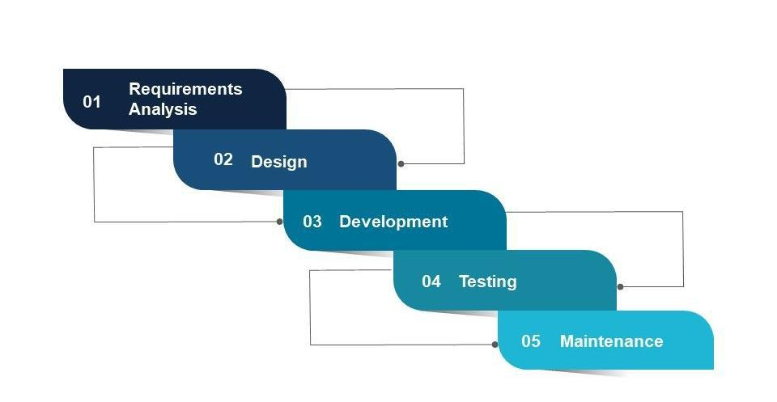

**Figure 1: Waterfall Model**

**Requirements Analysis**: At this stage, gathering detailed information about what this project requires. This information can be gathered in a variety of ways, including interviews, questionnaires, as well as interactive brainstorming.

**Design**: Creating the system based on the requirements that have been established. During this phase, no coding takes place, but the team establishes specifications such as programming language or hardware requirements.

**Development**: During this stage, coding takes place. Programmers take the information from the previous stage and turn it into a working product. They typically write code in small pieces that are integrated at the end of one phase or the beginning of the next.

**Testing**: Once all coding is done, testing of the product can begin. Testers find and report any problems in a systematic manner. If serious issues arise, the project may need to return to phase one for reevaluation.

**Maintenance**: The product was delivered to the client and is currently in use. As problems arise, we may be required to develop patches and updates to address them. Again, major issues may force a return to phase one.

Following are the reason behind using Waterfall Model as the development methodology:

* In this model, processes and results are well documented, clear and fixed.
* Technology and tools used are not dynamic and is stable. Requirement is clear.
* Easy to arrange tasks.
* Before the next phase of development, each phase must be completed. [5]

### 2. Working Mechanism of System

#### i. Data Modeling (ER-Diagram)

This ER (Entity Relationship) diagram represent the model of this project. It represents all the entity involved in the system and their relation among one another. There are four major entities names Admin, Customer, Futsal and Payment. Each entity has their own attributes representing the properties of the entity.

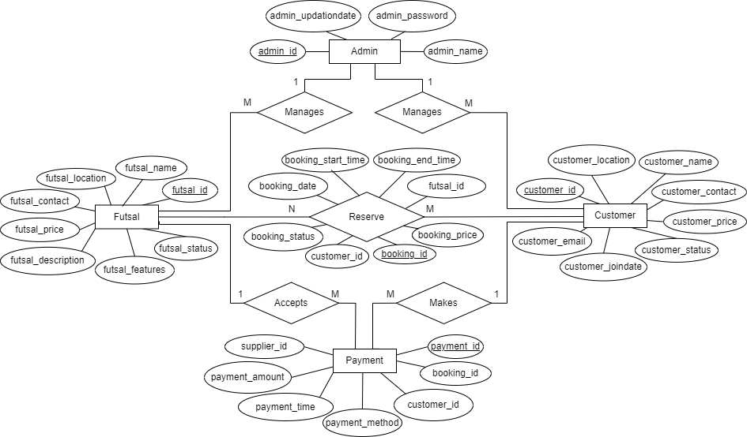

**Figure 2: ER-Diagram of FMS**

Customers can explore various futsal’s located in different locations where they can see their description, price, features and many more. And they can book the futsal at the available and suitable time where they all can play. When they book the futsal there are various methods for payment, a customer can choose anyone method and do the online transaction so that even if the customer doesn’t come, futsal owner should not get loss at their business.

In the above figure there are four entities they are Futsal, Customer, Payment and Admin. Here, each entity has their own attributes and attribute like id are set as primary key to make it unique. All Entities are connected through different relationships having their own specific works to perform. Here customer books a futsal and makes payment, futsal can accept/monitor the payment and they are booked by the customers whereas admin can manage both customers and futsal.

#### ii. Process Modeling (DFD Diagram)

Data Flow Diagram (DFD) shows the flow of data from external entities into the system, and from one process to another within the system. It is a tool used in software engineering to model, analyze, and design information systems. Following diagram is context diagram which is used for representing the flow of data in the FMS.

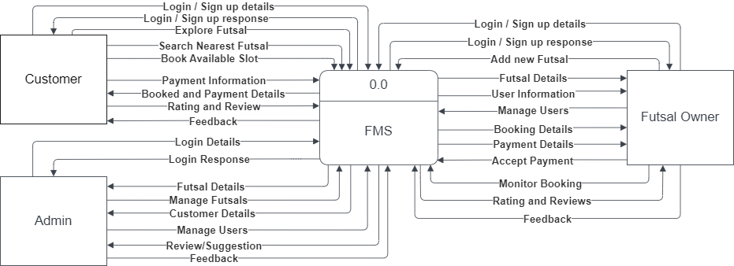

**Figure 3: Context Diagram of FMS**

In the above context diagram, we can see the overview of the whole system. Data to the system comes from three entity: admin, customer and futsal owner. Admin can login, manage the reviews, users and futsal. Users can login/signup, view futsal, booking, make and do payment actions, give rating to the futsal and can send reviews. Futsal owner can login/signup, add their futsal, give feedback, accept payments through different methods and can make their futsal available for booking.

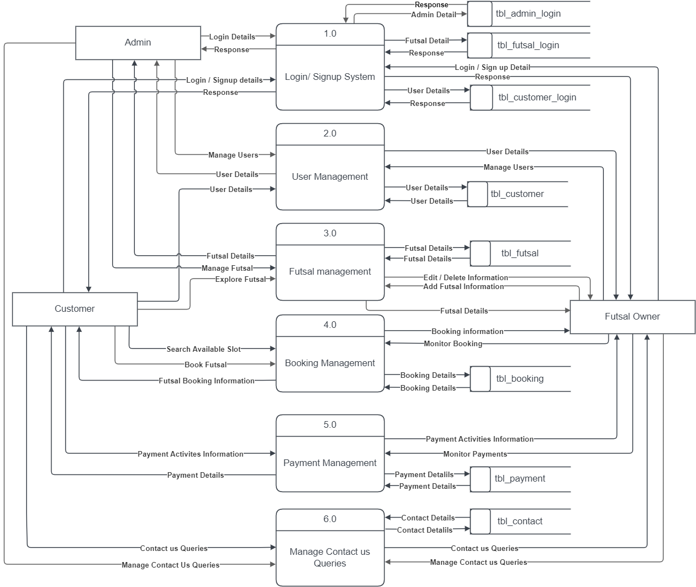

**Figure 4: Level 1 DFD of FMS**

In the above level 1 diagram, we can see the further breakdown of the system, there are six process, login/signup process, user management, futsal management, booking management, payment management and manage contact us queries. The data flow through these processes to perform all the functionalities of the application. To flow data through each process, tables in db are created where all the data are stored and retrieved whenever it is needed. The login/signup system, is responsible for user authentication and registration. The user management has all the data of customer so that they don’t have to put their details again and again for booking. Likewise, futsal management has also data of futsal so that any customer can explore them without any problems. The payment management is responsible for all type of transaction which will be performed under this system. At last, contact us system will contains data which are sent by customers so that futsal and admin can feedback them for better interactive of the system.

### 3. Description of Algorithm

There are many types of algorithms which can be implemented in this project but for now I’m using Geohashing algorithm. Geohashing is a way to encode a geographic location into a short string of characters, called a geohash, which can be easily shared, stored, or transmitted. Geohashing has a number of useful applications, such as location-based search, spatial indexing, and geotagging. [6]

The geohashing algorithm can be used in various projects where location-based data is needed. Here's how we can apply the geohashing algorithm in a project to know the location:

1. Collect the latitude and longitude coordinates of the location you want to encode.
2. Use the geohashing algorithm to convert the coordinates into a geohash string.
3. Store the geohash string in a database or other data storage system, along with any additional information you want to associate with the location.
4. When you want to retrieve the location, use the geohash string to look up the corresponding latitude and longitude coordinates.
5. Use the retrieved coordinates to display the location on a map or perform other location-based operations.

For example, to calculate the geohash code for the location (37.775,-122.419) with a precision level of 6, you would follow these steps:

1. Latitude: 37.775, Longitude: -122.419
2. Precision level: 6 (This will divide the world into cells of approximately 0.61km x 0.61km)
3. Convert latitude and longitude to binary:

Latitude: 100101.10011

Longitude: -1111001.10101

1. Interleave binary digits to create single binary string: 1-1-0-0-1-1-1-1-0-1-0-1-0-0-1-1-0-0-1-0-1-1-1-0-0-1-0-1-0-1-0-1
2. Divide binary string into groups of 5 bits: 11111 00111 11010 10111 11000 10100 10101 01101 00010 11010 11101 00001 11010 10110
3. Convert each group of 5 bits into a corresponding base-32 character: wu2g5m1b8vzs
4. Concatenate base-32 characters to create final geohash code: wu2g5m

In this project, Geohashing algorithms can be used to track the location of futsal courts. This can help the customers to optimize their resources by identifying the most popular and nearest locations and booked the futsal according to it. This can help to reduce travel times and expenses, as well as optimize the scheduling of matches based on player and facility availability.

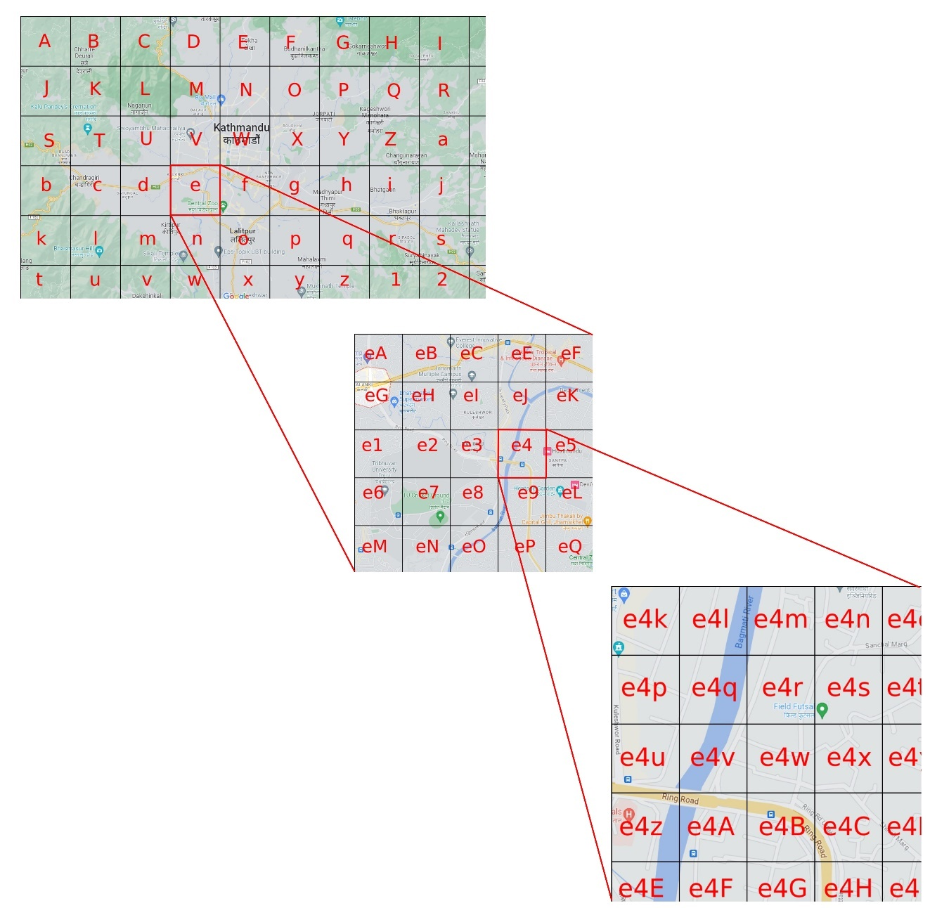

**Figure 5: Geohashing Algorithm Explanation**

In the above figure we got the map of Kathmandu, where we made cells with different characters to make them specific. As we need a place where we have specified ‘e’ character, we magnified it and got many characters which is followed by ‘e’. Again, we need a place inside ‘e4’ therefore we again magnified it. Likewise, we’ll get the place we want to when magnified more often. The more the digit, the accurate result we’ll get. In short, the geohashing algorithm can be a useful tool for encoding and storing location-based data in a compact and efficient way.

### 4. System Developments Tools

System development tools refer to software programs, frameworks, and utilities used by developers and software engineers during the process of designing, building, testing, and maintaining software systems. These tools aid in coding, collaboration, debugging, testing, and deployment, enabling developers to create efficient and high-quality software systems.

The following tools will be used to develop the project.

**Frontend Technology:**

* HTML
* CSS
* JavaScript
* React
* Redux

**Backend Technology:**

* JAVA
* Spring Framework

**Database:**

* MySQL

**Designing tools:**

* Figma
* Photoshop

**Documentation tool:**

* MS Word
* MS PowerPoint
* Project Libre

**IDE:**

* Intellij IDEA
* Visual Studio Code

# Gantt Chart

Gantt chart is a type of bar chart that illustrate a project schedule. It is a popular in project management which is useful for showing activities against the time. Gantt charts illustrate the start and finish dates of the terminal elements and summary elements of a project. Each activity is represented by a bar. The position and length of the bar shows the start date, duration and end date of the activity. [7]

**Table 2 : Gantt Table of FMS**

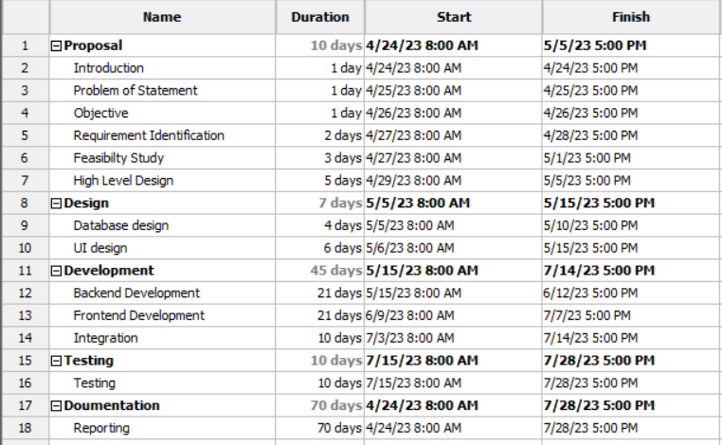

From above table we can make a bar chart that provides a visual view of tasks scheduled over time. The schedule of the project is represented by the figure below:

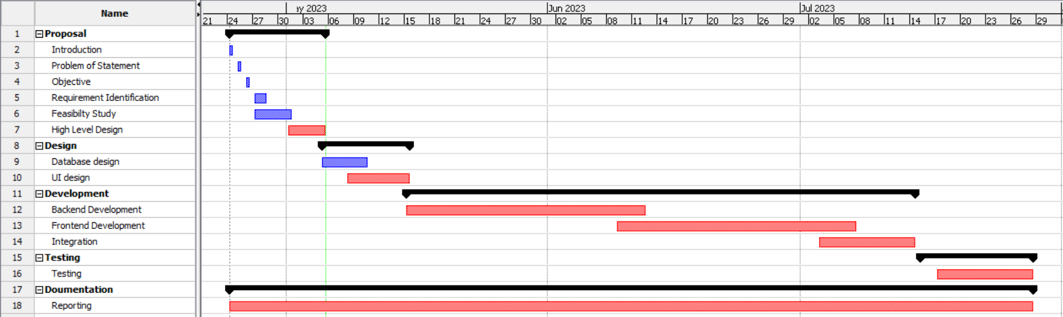

**Figure 6:Gantt Chart of FMS**

In this project, we first started the planning of this project with writing proposal for the first 10 days. Then we will proceed for designing and development for next 50 days where we will perform different task such as requirement analysis, feasibility study, diagrams and designing, development, implementation and many more.

# Expected Outcome

FMS is designed to manage the operations and activities of a futsal court, including reservations, payments, and scheduling. The expected outcome of a Futsal management system would depend on the specific requirements and features of the system where customers can easily reserve a futsal court online, view available time slots, and pay for their reservation.

The system can securely process payments for reservations of futsal and provide users with receipts and invoices. The system can track the status of each court, including availability, features, and time schedules and can generate reports on reservations, revenue, and other key performance indicators, allowing the futsal court owners to make informed business decisions. It helps to find the nearest futsal with navigation system from map which help to find the futsal easily to the customers.

At last, the expected outcome of a FMS is to provide a seamless and efficient experience for futsal court users and owners, improving the overall operations and profitability of the business.

# References

|  |  |
| --- | --- |
| [1] | "Hamro Futsal," [Online]. Available: https://www.hamrofutsal.com.np. [Accessed 18 March 2023]. |
| [2] | "Researchgate.net," Li et al., 2018. [Online]. Available: https://www.researchgate.net/publication/270608340_A_Systematic_Review_of_Futsal. [Accessed 28 April 2023]. |
| [3] | "Researchgate," Mohamad et al, 2020. [Online]. Available: https://www.researchgate.net/publication/Mobile_application_for_the_futsal. [Accessed 28 April 2023]. |
| [4] | "ResearchGate," Study by Pires et al, 2020. [Online]. Available: https://www.researchgate.net/publication/Mobile_application_for_the_futsal. [Accessed 1 May 2023]. |
| [5] | "Slideteam.net," SDLC-Waterfall Model, [Online]. Available: https://www.slideteam.net/system-development-lifecycle-waterfall-model-ppt-sample. [Accessed 3 May 2023]. |
| [6] | "Medium.com," Geohashing Algorithm, Information, Features and uses , [Online]. Available: https://medium.com/@bkawk/geohashing-20b282fc9655. [Accessed 4 May 2023]. |
| [7] | "Wikipedia.org," Gantt Chart Software, Information, and History. , [Online]. Available: https://en.wikipedia.org/wiki/Gantt_chart.. [Accessed 6 May 2023]. |